Course Information
Course Number: DAEN 459
Course Title: Capstone Senior Design Planning
Section: 500
Time / Location: MW 9:10-10:00 AM / ZACH 211, F 9:10-11:10 AM / ZACH 344
Credit Hours: 3 (2 hours of lecture, 3 hours of lab per week)

Instructor
Instructor: Alexander Abuabara
Email: abuabara@tamu.edu Zoom: https://tamu.zoom.us/my/abuabara
Office: ETB 4013 Office Hours: W 1:00-3:00 PM (or by appointment)

Course Description
First in a two-course sequence for the capstone senior design experience; formation of a senior design team, visitation with the team sponsor, preparation of the groundwork for the project, preparation of the project charter and collection or acquisition of initial set of data; provision of instructions on different aspects of capstone design, including ethics, design constraints, applicable standards, project management, report writing specifications and requirements, and oral and visual presentations.

Learning Outcomes
By the end of the course, students should have:
- a fully scoped capstone project,
- sponsor-approved requirements,
- architecture and infrastructure plans,
- initial datasets collected/acquired,
- governance and ethics analysis,
- project schedule and risk plan,
- prototype or proof-of-concept,
- professional proposal and presentation.

Pedagogical Model
Semester 1 (DAEN 459) = "Design and De-risk" | Semester 2 (DAEN 460) = “Build and Deploy”
Students should:  - Define the problem,  - Acquire data,  - Validate feasibility,  - Design the system,  - Produce operational plans. | Students should:  - Implement,  - Test,  - Iterate,  - Evaluate,  - Present final system.

Why I Teach this Course
This course offers you a unique learning experience. I am always especially excited to teach this course, here is why:
- You finally get to combine everything that you have learned throughout your entire undergraduate curriculum. This not only includes the data engineering skills you have gained, but also the professional, cultural, and communication skills that you have developed.
- This is an opportunity for you to try to solve a problem that matters to you. This course gives you a lot of freedom and choice in an extensive project. This course can be the first step towards moving to the career of your choice.
- Building a system from start to finish is fun and rewarding. Students often tell me that this was the greatest experience of their entire college career.
- Working on teams can be messy, but it's worth it. It is amazing what you can accomplish together, so much more than on your own. Working on real problems with real people has its challenges, but it is also very rewarding when you successfully complete your goals.
- Every semester is different, every team is different, every solution is different. There is always something new to learn and innovate.
- Smaller class sizes and weekly meetings allow you to connect with your classmates and your instructor(s).

Course Prerequisites Course Corequisites Special Course Designation
Grade of C or better in DAEN 301 DAEN 400, DAEN 427, and DAEN 429 None

Course Expectations
As a data engineering student, you are expected to apply the skills and knowledge developed throughout your academic career toward the planning and development of a substantial, real-world data-centric project. These expectations mirror professional data engineering roles, preparing you for collaborative, cross-functional work. You are expected to:
- Contribute actively to your team with clear communication, accountability, and collaboration,
- Attend all meetings, meet deadlines, contribute to team decisions, and resolve conflicts professionally,
- Work with stakeholders to define and refine technical and business requirements,
- Develop a detailed project plan with timelines, data needs, and deliverables,
- Address ethical, privacy, and risk considerations,
- Identify, acquire, clean, and validate datasets, including the elaboration of data dictionaries and relevant metadata,
- Design a robust data architecture, including storage, pipelines, and processing frameworks,
- Document data flow, system architecture, and all planning and data engineering decisions with supportive analysis,
- Present project components clearly to both technical and non-technical audiences,
- Deliver a comprehensive design proposal with diagrams, models, and a clear roadmap,
- Track progress through milestone reviews and maintain an updated project board,
- Manage scope, time, and resources, adjusting plans as needed,
- Apply best practices in version control, reproducibility, and testing,
- Ensure compliance with industry standards, regulations, and school policies, and
- End the course with a feasible, well-scoped project ready for implementation.

Recommended/Reference Textbooks
Available free online at TAMU Libraries:
- Design of Everyday Things. D. Norman (2013)
- Universal Principles of Design. W. Lidwell, K. Holden, J. Butler (2023)
- Tragic Design: The Impact of Bad Product Design and How to Fix It. J. Shariat, C. Savard Saucier (2017)
- Fundamentals of Data Engineering. J. Reis, M. Housley (2022)
- Designing Data-Intensive Applications. M. Kleppmann (2017)
- The Data Warehouse Toolkit. R. Kimball, M. Ross (2013)

Grading Policy
- Graded items and weights:
Deliverable |  | Weight
1. Professionalism and participation | Individual | 10%
2. Team agreement | Individual | 0%
3. Sponsor meeting notes | Individual | 5%
4. Problem statement and project objectives | Team | 10%
5. Draft project charter | Team | 0%
6. Ethics, privacy, and risk assessment | Individual | 10%
7. Data requirements and acquisition plan | Team | 10%
8. Initial data inventory and profiling report | Team | 5%
9. Preliminary system/data architecture | Team | 10%
10. Requirements and constraints matrix | Team | 10%
11. Work breakdown structure and project schedule | Team | 10%
12. Risk register and mitigation plan | Individual | 10%
13. Evaluation and verification plan | Team | 10%
15. Draft planning report and presentation | Team | 0%
15. Final planning report, charter, presentation, and DAEN 460 transition package | Team | 15%

- In addition to the graded items listed above, other submissions will be evaluated on a satisfactory/unsatisfactory basis. Details of these requirements and milestones will be posted on the Canvas course page and may include review sessions as well as meetings with sponsors and advisors to discuss strategies.
- Grades will be calculated by totaling the points you earn and comparing them to the max. possible points.
- Grades assigned are A: 90%–100%, B: 80%–89.9%, C: 70%–79.9%, D: 60%–69.9% and F for less than 60%.

Late Work Policy
Late work will not be accepted except for approved university excused absences. Excused absences apply only to attendance and in-class activities and do not extend assignment deadlines. Alternatives must be arranged prior to deadline. Late work will be assigned a score of zero. Disagreements regarding a grade received on any graded material must be discussed within one week of the return of the graded material. No grade will be changed beyond this limit. If you request a regrade, the entire submission will be regarded.

Course Assignments
Initial guidelines are in the appendix; detailed instructions will be shared in class.

Professionalism and participation means being responsible, prepared, and actively involved throughout the project. This includes attending meetings, completing assigned tasks on time, communicating clearly with teammates and instructors, accepting feedback, and contributing ideas to solve problems. Professionalism also means producing accurate and organized work, following ethical practices when handling data, and using appropriate technical tools and documentation. Strong participation shows that a student is dependable, works well with others, and contributes consistently to the success of the project.

All submissions and presentations are formal, graded deliverables and must be uploaded to Canvas as assigned. All team members must participate, with leadership rotating across the team. Teams should hold a brief debrief after presentations.
The course concludes with a final poster presentation of each team's capstone project plan. All DAEN capstone teams participate.

Teams are formed by the instructor based on preferences or direct project assignment. Each team has an ISEN faculty advisor, with the instructor guiding the course and the sponsor serving as the client.

Faculty Advisor – Each team must have a faculty advisor from the ISEN department, and the instructor can suggest advisors who fit the project. The advisor is your subject matter expert, offering guidance and suggestions along the way. Teams should meet with their advisor every two weeks unless the advisor approves a different schedule. Faculty advisors are actively involved and considered part of your team, so treat them with respect and courtesy.

Additional Faculty Advisor – Teams can add a secondary advisor after checking with the course instructor. These advisors can be from any Texas A&M department or affiliated organization. If you want an advisor from outside Texas A&M, you'll need written approval from the instructor. The request should include their name, email, phone number, organization, area of expertise, and a short explanation of why their help would be valuable.

Course Material and Copyright
All documents used in this course are copyrighted. Here, "documents" means all materials generated for this class, including, but not limited to, course syllabi, course notes, quizzes, exams, problem sets, slide sets, and all materials appearing on the Canvas website or sent to you via email. Because these materials are copyrighted, you do not have the right to copy any of them for any purpose other than your own personal academic use unless the instructor expressly grants permission. Course materials may not be given or sold to any for-profit enterprise.

Confidentiality and Non-attribution
In this course, we will often use client data, project details, or conversations that need to stay within our group. You can share this information with classmates and the teaching team, but not outside the course. To keep things confidential, store notes or files in a safe way (like a folder, binder, or password-protected device) and keep them with you or in a secure place (room, backpack, car). Non-attribution means focusing on ideas, not people. Instead of saying "José said Range Rovers have reliability issues," say "I understand that Range Rovers have reliability issues." Avoid tying insights to individuals or teams.

Attendance & Class Participation
During the first two weeks, everyone meets during regular class time. Once teams are set, each team will give a technical review about every two weeks, and you're encouraged to attend other teams' sessions to see their work. The instructor may adjust the schedule or add events as needed. Attendance is required for all class sessions, sponsor meetings, and presentation days, unless you have a university-excused absence (see https://student-rules.tamu.edu/rule07).

Team Meetings – Active engagement is a key part of the capstone experience. Students are expected to fully participate in all team activities, including meetings with sponsors, faculty advisors, and internal discussions. These interactions help the project succeed while giving you opportunities to collaborate, solve problems, and practice professional communication skills. Meaningful participation benefits both you and your team throughout the course.

In team projects, everyone is expected to contribute fairly. When someone doesn't, the rest of the team carries the burden, which isn't fair. This problem, often called social loafing, can take many forms:
- Ignoring emails, texts, or calls from the team.
- Being told there's a communication issue but not fixing it.
- Expecting the team to work around your personal schedule.
- Missing meetings, showing up late, or leaving early.
- Submitting work that is incomplete, full of mistakes, or unusable.
- Working on unrelated ideas without team approval, then expecting credit.
- Attending meetings but spending more time on your phone than participating.

What’s expected of you:
- Be available, stay in touch with your team. It's your responsibility to make sure communication works.
- Do your part! All must contribute a fair share of the project. Fair doesn't always mean equal. Tasks may vary. Teams are encouraged to assign work that fits members' skills, but everyone must contribute in a meaningful way. Participation (or lack of it) will be reflected in presentations and peer reviews.
- Always show courtesy and respect! Professional behavior is always expected. Teammates are colleagues, use respectful language, and contribute in a way that shows maturity and responsibility.
- If a student consistently fails to participate, faculty may move them into a Track B Option: working alone under direct supervision. In this track, the highest possible grade is a C (if all requirements are met).
- Speak up early! If a teammate still isn't contributing after a TA discussion, let faculty know right away. Problems don't fix themselves, and waiting until the end of the semester leaves no time for solutions.

Project Sponsor Interaction – Teams should meet with the project sponsor's point of contact (POC) about once a month, adjusting as needed for the sponsor's schedule. Meetings can be by phone or video call (email doesn't count). All team members should attend unless there's a university-excused absence or a class conflict. The team and sponsor will coordinate meeting times, and only the sponsor can cancel. If a meeting is canceled or the sponsor feels the schedule isn't working, note it in your technical presentations and discuss a solution with the instructor.

Courses Schedule (Tentative)
DAEN 459
Week | Topics | Team / Lab activities | Milestones / Deliverables
1 | Capstone expectations; design process; professional conduct | Review sponsor projects; skills and interest inventory | Individual skills profile and project preferences
2 | Team formation; teamwork; roles and responsibilities | Form teams; select projects; establish communication practices | Team agreement and preliminary role assignments
3 | Sponsor engagement; stakeholder analysis; effective interviewing | Initial sponsor meeting; identify stakeholders and decision context | Sponsor meeting notes and stakeholder register
4 | Problem framing; needs assessment; requirements elicitation | Translate sponsor needs into a preliminary problem statement | Problem statement and project objectives
5 | Project charters; scope definition; assumptions and constraints | Define scope, exclusions, success criteria, and major deliverables | Draft project charter
6 | Ethics, privacy, security, bias, and responsible data use | Conduct ethical and data-governance review | Ethics, privacy, and risk assessment
7 | Data requirements; data provenance; acquisition strategies | Inventory available data; identify gaps and access dependencies | Data requirements and acquisition plan
8 | Initial data collection and profiling | Acquire an initial dataset; assess schema, quality, completeness, and suitability | Initial data inventory and profiling report
9 | Data engineering architecture and tool selection | Develop source-to-output architecture; evaluate platforms and tools | Preliminary system/data architecture
10 | Applicable standards; legal, organizational, and design constraints | Identify standards and convert constraints into requirements | Requirements and constraints matrix
11 | Project management; work breakdown structures; estimation | Develop tasks, dependencies, schedule, ownership, and communication plan | Work breakdown structure and project schedule
12 | Risk management; feasibility; change control | Assess technical, data, schedule, personnel, and sponsor risks | Risk register and mitigation plan
13 | Evaluation planning; alternatives; metrics and acceptance criteria | Define baseline, alternatives, validation methods, and performance measures | Evaluation and verification plan
14 | Technical writing; visual communication; design reviews | Integrate planning artifacts; peer and instructor design review | Draft planning report and presentation
15 | Professional presentations; transition to implementation | Formal sponsor presentation; revise plans based on feedback | Final planning report, charter, presentation, and DAEN 460 transition package

DAEN 460
Week | Topics | Team / Lab activities | Milestones / Deliverables
1 | Project reactivation; execution expectations; configuration management | Reconfirm scope, roles, sponsor expectations, data access, and schedule | Updated project plan and kickoff memorandum
2 | Reproducible development; repositories; testing strategy | Configure development environment, repository workflow, and issue tracking | Reproducibility and testing plan
3 | Data ingestion and acquisition | Implement source connections and initial ingestion processes | Working ingestion prototype
4 | Data quality engineering; validation and observability | Implement schema, completeness, accuracy, and anomaly checks | Data-quality rules and baseline assessment
5 | Data transformation; integration; metadata and lineage | Build repeatable cleaning, transformation, and integration workflows | End-to-end pipeline increment 1, PRESENTATION 1
6 | Storage, data modeling, performance, and security | Implement storage/modeling layer; review access controls | Architecture and implementation review
7 | Exploratory analysis; baselines; analytical validity | Establish descriptive findings and baseline performance | Technical progress report 1
8 | Midsemester design review | Demonstrate pipeline and preliminary analysis to faculty and sponsor | Working prototype, Midterm PRESENTATION 2
9 | Application of analytical or data engineering methods | Implement primary models, algorithms, or decision-support methods | Analysis/modeling increment 1
10 | Alternative designs; trade-off analysis; design constraints | Compare approaches using technical and stakeholder criteria | Alternatives and trade-off analysis
11 | Verification, validation, testing, and uncertainty | Perform system tests, sensitivity analysis, error analysis, or model validation | Validation and testing report, PRESENTATION 3
12 | Interpretation; recommendations; operational implications | Convert results into sponsor-relevant findings and recommendations | Draft findings and recommendations
13 | Deployment, maintainability, documentation, and handoff | Package pipeline, code, dashboard, model, or other product for sponsor use | Release candidate and technical documentation
14 | Report writing; presentation design; peer review | Conduct final technical review and rehearsal; resolve remaining defects | Draft final report, PRESENTATION 4
15 | Final design presentation and project handoff | Present results; demonstrate product; transfer artifacts to sponsor | Final report, showcase presentation, product, repository, and sponsor handoff

Important Dates (https://registrar.tamu.edu/Academic-Calendar)
• Aug 24 | First day of Fall semester classes | • Nov 26-27 | Thanksgiving holiday, no classes
• Aug 28 | Last day to add/drop courses for Fall semester | • Dec 3 | Last day of Fall semester classes
• Sep 7 | Labor day, no classes | • Dec 4 | Reading day, no classes
• Nov 25 | Reading day, no classes | • Dec 7-10 | Final exams

Tips – (i) Be nice. Be honest. Don't cheat. Adhere to all University Policies. (ii) You all are important to me: include the course number in email subject so I can prioritize it. (iii) Every step matter and each build on the next: stay engaged, keep up, ask questions. (iv) Learning takes steady effort: start early, not last-minute cramming. (v) Engineers turn data into meaningful information, practice here, get prepared. (vi) Clear, well-organized work is as important as the content itself. (vii) Use others' ideas to build your own but always credit your sources: good scholarship means giving credit where it's due. (viii) No audio or video recording without permission; it's a conduct violation otherwise.

Technology Support – For technical support contact isen-helpdesk@tamu.edu.

Initial guidelines
This capstone course serves as an integrative, high-impact educational experience that challenges students to integrate their accumulated knowledge and apply it to a complex, real-world problem. The capstone projects encourage students to adopt a hands-on approach by building solutions from the ground up rather than relying only on existing tools or templates. The goal is to improve essential skills such as project management, communication, and interdisciplinary analysis, thereby preparing students for professional or academic success. Figure 1 provides a broad overview of how data moves through a system, highlighting the sequential steps of data engineering and the critical underlying disciplines that ensure its success.

Unlike busy work which often involves repetitive, low-cognitive tasks with limited connection to meaningful learning outcomes, the capstone project demands critical thinking, research, and collaboration. Here "reinventing the wheel" is not busy work but a deliberate method for gaining insights, building confidence, and preparing for real-world innovation. Drawing inspiration from Richard Feynman's quote, "What I cannot create, I do not understand", these are some of the great reasons to reinvent the wheel:
- Learn how wheels are made
- Teach others about wheels
- Learn about the inventors of wheels
- Be able to change wheels (or fix) when they break
- Build a better wheel (for some definition of better)
- Help someone in need of a very special wheel (maybe for a wheelchair?)
- Learn a tiny slice of what it means to build a larger system (such as a vehicle)

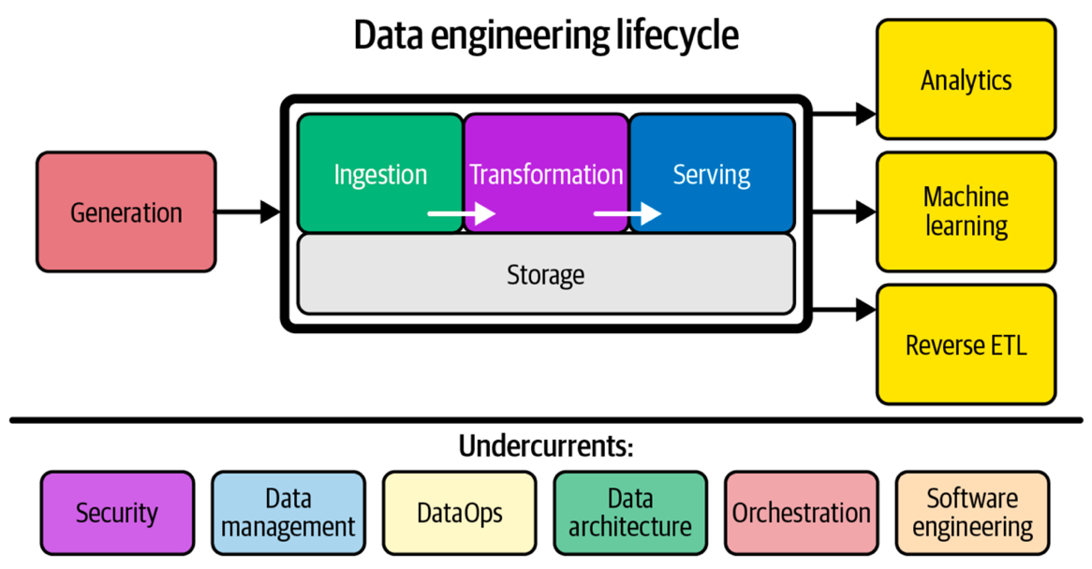
Figure 1 – Components and undercurrents of the data engineering lifecycle. Image extracted from Fundamentals of Data Engineering: Plan and Build Robust Data Systems, J. Reis, M. Housley, 2022.

V-model
The V-model (Fig. 2) provides a structured framework ideal for planning the Data Engineering Capstone Senior Design courses. It guides students from defining project goals and requirements to detailed system design and implementation. This model promotes a detailed and careful planning, iterative development, and continuous verification, helping students understand the full lifecycle of a data engineering system, from concept and design to deployment and maintenance. Each phase on the left is mirrored by corresponding testing and validation on the right, ensuring alignment between design and outcome.
Within this framework, a Project Charter is typically the first formal document, authorizing the work, defining objectives, scope, stakeholders, and approach, and giving each team the authority to access necessary resources and tools. Once the charter is approved, the Project Management Packet is assembled, detailing schedules, risks, communications, and other operational plans, and ensuring execution stays consistent with the V-model. Like a movie, the charter is the green light; the packet is the production plan. Below you have more details about the Project Charter and the Project Management Pack.

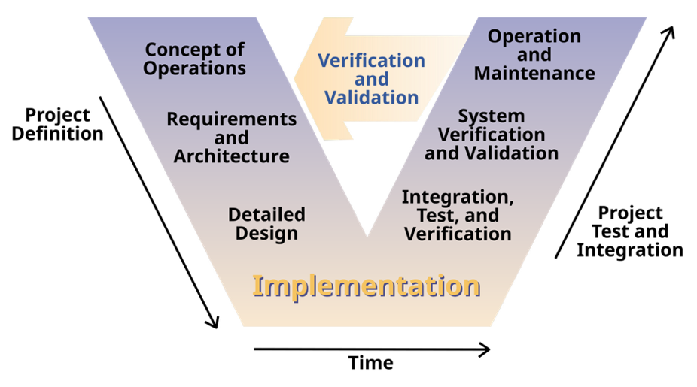
Figure 2 – Systems Engineering Process. Image extracted from Clarus: Concept of Operations, Federal Highway Administration (FHWA), 2005. (Publication No. FHWA-JPO-05-072, authors: L. Osborne, J. Brummond, R. Hart, M. Zarean, S. Conger.)

1. Project Charter
The Project Charter is a concise, authoritative document that formally authorizes a project. In a two-semester capstone sequence, the final sponsor-signed charter is the green light to proceed to implementation in the second capstone semester. Endorsed by the project sponsor, it grants the project manager and team the authority to commit organizational resources and establishes a common understanding of the project's purpose, scope, and constraints. Treat the charter as both a contract and a living reference; if conditions change, revise it formally rather than drifting informally. These are important aspects that need to be addressed in the charter:
- Authority & accountability: Sponsor sign-off clarifies who owns vision and acceptance.
- Unified vision: Forces the team to articulate a shared understanding before deep technical work.
- Baseline for changes: Scope or resource changes must be justified against the charter, avoiding unpleasant surprises.
- Early risks: Listing assumptions and constraints reveals potential (ethical/legal/technical) risks early enough to plan.
- Communication tool: Because it is short, executives and non-technical stakeholders will actually read it.

2. Project Management Packet
The Project Management (PM) Packet is a single living document that guides a data-engineering capstone team from idea approval through final hand-off. Think of it as the project's constitution that captures what you will build, how, by whom, and when so faculty, sponsors, and teammates always have one authoritative source of truth. Keep the packet lean (about 10 pages) and version-controlled, and revisit it whenever scope, risks, or constraints change. A well-maintained packet not only streamlines your work, but it also showcases professional project-management discipline to future employers. How it's used:
- Proposal phase: Submitted with your charter to secure faculty and sponsor sign-off.
- Execution phase: Updated after each sprint review; serves as the agenda for weekly stand-ups.
- Evaluation phase: Forms the backbone of your final report and memo, proving objectives were met.

Key components of the PM package and their functions:
- Work Description: Plain-language summary of what the team will build or analyze.
- Deliverables: Defines concrete outputs (code, datasets, report, poster) to hand over.
- Project Boundaries: States what is in and out to guard against scope creep.
- Acceptance Criteria: Minimum conditions the sponsor must see to sign off.
- Constraints: Non-negotiable limits (tools, data privacy, semester length, etc.).
- Assumptions: Conditions taken as true (e.g. data access) that may later change.
- Quality and Performance Metrics: How accuracy, reliability, and efficiency will be judged.
- Metrics & Verification Methods: How each metric will be measured, tested, and logged.
- Timeline and Milestones: Semester checkpoints that trigger progress reviews and pivots.
- Task Priority: Ranks tasks so critical-path items are tackled first.
- Risks & Risk Management Plans: Lists top pitfalls and the team's mitigation / contingency moves.
- Cost Estimates and Budgeting: Forecasts hours, cloud credits, and purchases to stay on budget.
- Resources: People, software, hardware, and data the project will rely on.

